# e-Project

# Safe Carz Ltd

**Submitted To**

[eprojects@aptech.ac.in](mailto:eprojects@aptech.ac.in)

**Project Instructor**

Syed Danial Nabi

**BATCHCODE**CF201610B

**Group Members**

Aqib Siddique

Muhammad Farhan Bakht

Syed Bilal

Abdul Wahab



# Project Certification

This is to certify that,

Aqib Siddique

Muhammad Farhan Bakht

Syed Bilal

Abdul Wahab

have successfully Designed & Developed

**Safe Carz Ltd**

Submitted by:

**Aqib Siddique, Muhammad Farhan Bakht, Syed Bilal, Abdul Wahab.**

Date of Issue:

**4-april-2016**

Authorized Signature: **Mr. SYED DANIAL NABI**

**Acknowledgement:**

We like to thank many people who helped us in completing this project. Foremost I would like to thank Almighty Allah for giving us strength and ability to complete this project. We would like to express our gratitude to all those who gave us the possibility to complete this website and we want to thank the Department of faculty for helping us to do the necessary research. We furthermore, thank our class teacher Sir. Danial Nabi Islam for giving us completes support and advising us in the project. Especially, we would like to thank to our colleagues for the valuable suggestions.

**Thank You.**

**Table of Contents**

Project Certification 2

Problem Definition 4

Customer Requirement Specification 5

Project Duration 6

Task Sheet 7

List of Validation 9

Submission Checklist 0

Screen Shots 11

**Source code……………………………………………………………………………………13**

# 

**Problem Statement**

Safe Carz Limited is into providing insurance cover for Cars and other vehicles. They provide various insurance policies through different Insurance companies. They now want to provide details of these insurance products on internet. They want to host a website with all the information about their organization and various insurance plans available with them.

**Requirement Specification:**

The Web site is to be created based on the following requirements.

1. Home Page should contain logo of the site with proper sections and details of various Insurance plans available.
2. The site should display a menu which will contain the options for brief introduction about the various categories and plans available, location of the shop and any other information if required.
3. The information should be categorized according to the company names of the Insurance plans like if a User wants to see only “Zurich Insurance” plans or any other company’s insurance plans then he/she can click on a Link/button/menu etc and can see only that Companies plans .
4. Another category option for plans of different type of vehicles, like ‘Four Wheelers’, ‘Two Wheelers’ etc. should be created and accordingly.
5. When a user selects any particular brand, a list of various plans for that brand will be displayed
6. A brief summary about individual plans should be displayed on the Web Page along with the base price.
7. There should be a “Contact Us” page which will have the Address of the Store which is as follows and the mail address which when clicked will invoke the local mail client from where they can send an email.

#Plan = Insurance Plan / Insurance Product

**HARDWARE/SOFTWARE REQUIREMENTS:**

**Hardware**

* A minimum computer system that will help you access all the tools in the courses is a Pentium 4 or better
* 512 Megabytes of RAM or better

**Software**

* Notepad/HTML editor
* Dream weaver
* IE 5.0/ Netscape 6.0/Firefox/Chorome

**SCOPE OF THE WORK:**

The Features should be stored in Individual Word documents which can be downloaded or Web site is to be created based on the following requirements.

# Project Duration

1. Analysis-18 Hrs.
2. Design – 22 Hrs.
3. Development –20Hrs
4. Testing – 12 Hrs
5. Documentation -11 hrs

# Task Sheet

|  |  |  |  |  |  |
| --- | --- | --- | --- | --- | --- |
| **No.** | **Task** | **Actual Start Date** | **Actual Days** | **Team Mate Name** | **Status** |
| 1. | Case Study | 1thOct 2014 | 1 | Aqib Siddique  Farhan Bkaht  Syed Bilal  Abdul Wahab | Completed |
| 2. | Graphics Designing | 12thOct 2014 | 2 | Muhammad Farhan Bakht | Completed |
| 3. | Site Interface Designing | 15thOct 2014 | 3 | Farhan, Aqib | Completed |
| 4. | Material Searching | 16ndOct 2014 | 2 | Bilal | Completed |
| 5. | Site Testing/Publishing | 18thOct 2014 | 4 | Aqib,Bilal,Farhan,Wahab | Completed |
| 6. | Documentation | 21thOct 2014 | 2 | Bilal | Completed |

# List of Validation

|  |  |
| --- | --- |
| Option | Validation |
| Fields in Form should not be Null | Yes |
| Hyperlinks Have Alternating Text | No |
| Search Pages | No |
| Homepage Has Forward Only Link | Yes |
| All Web pages have link back to Homepage | Yes |
| All Functions Are Compatible with Chrome | Yes |
| All Functions Are Compatible with Firefox | Yes |
| All Functions Are Compatible with IE | No |

# Submission Checklist

|  |  |  |  |
| --- | --- | --- | --- |
| **S.NO** | **LIST OF ITEMS** | **Remarks** | **COMMENTS** |
| 1. | Do All Pages Linked together | **Yes** | On Self Target |
| 2. | All Hyperlinks working | **Yes** | On same or Different Div |
| 3. | Page Colors As Per Common Guidelines | **Yes** |  |
| 4. | Site Browser Compatible | **Yes** | Internet explorer required Active X |
| 5. | Image Slicing | **Yes** | Using Adobe Photoshop, |
| 6. | Project Zip File | **Yes** | Created using Winrar |

# snap shots

**Header And Nav**

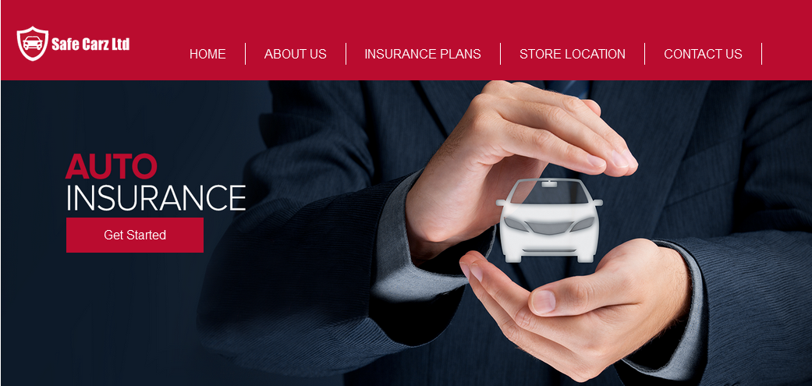

Section Upper

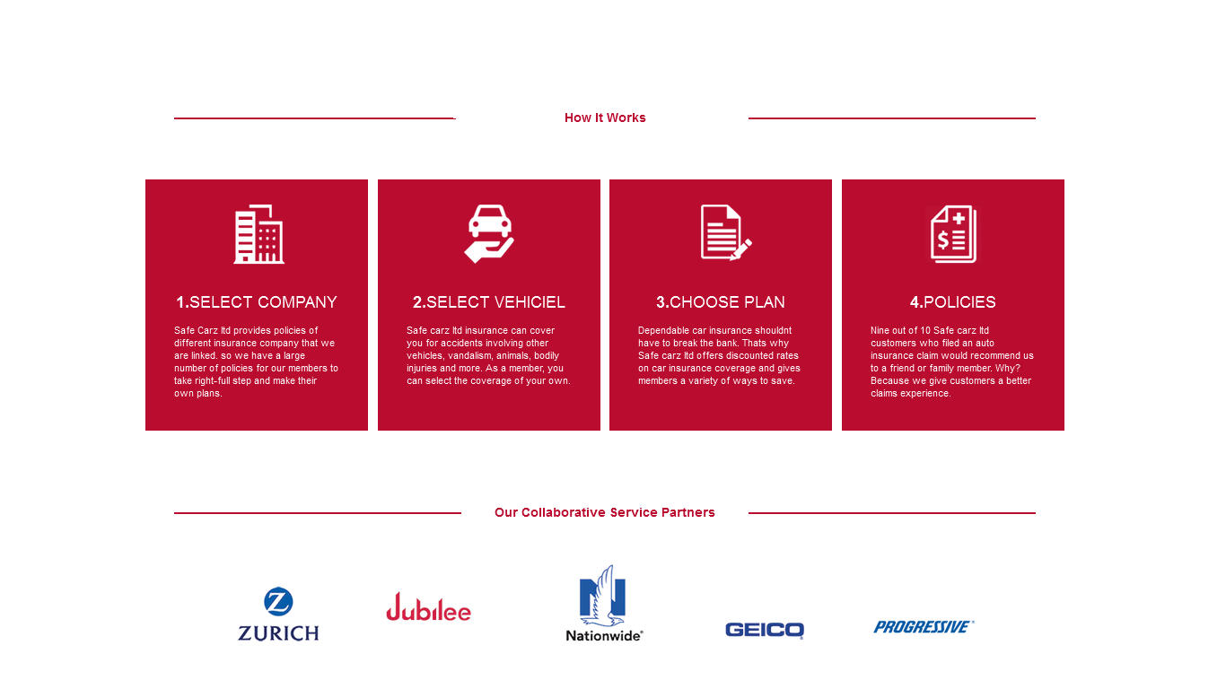

Section Lower And Footer

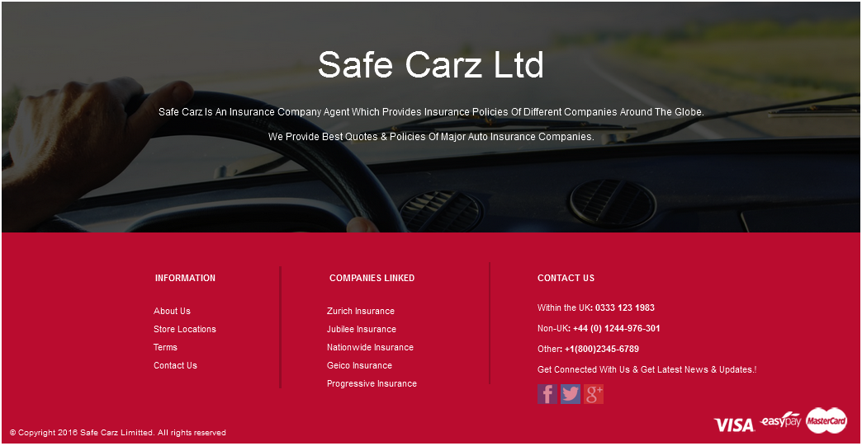

Source Code # 1

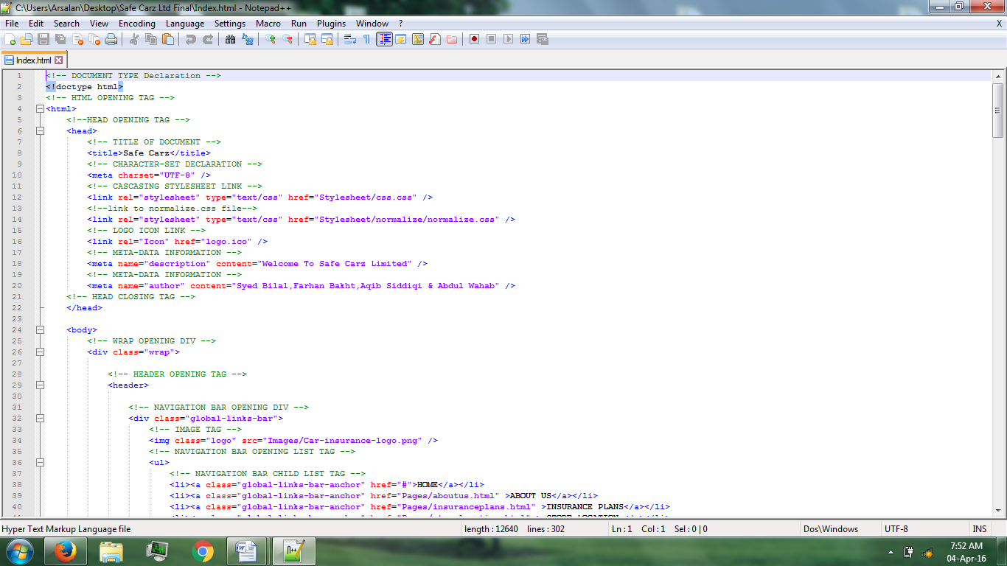

Source Code # 2

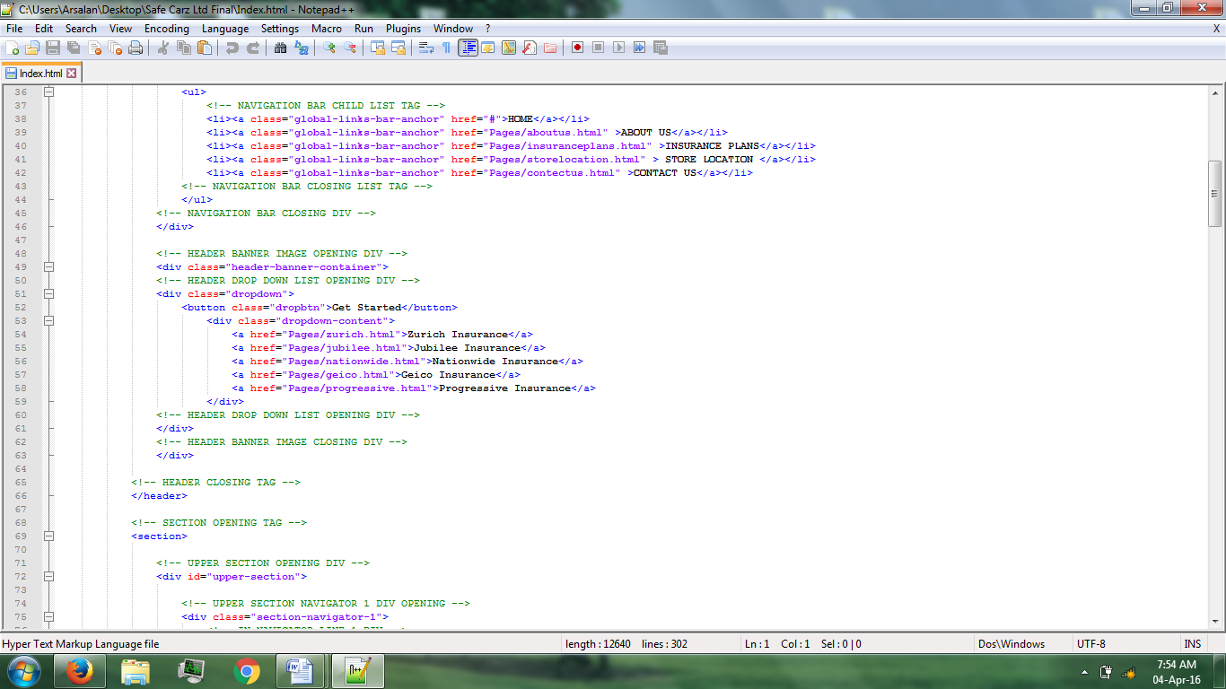

Source Code # 3

